**FINAL REPORT**

**FOR**

**DATA-DRIVEN STUDY OF KENYA’S EXCHANGE RATE DYNAMICS**

**UNDERSTANDING THE FORCES SHAPING KENYA’S CURRENCY VALUATIONS**

**Introduction**

Exchange rates play a critical role in shaping the economic terrain of nations. This project adopts an exploratory approach to identify how and the extent to which different factors influence Kenya’s exchange rate movements, and potentially try to forecast future movements.

**Objectives**

1. To conduct exploratory data analysis (EDA) on the USD/KES exchange rate from 2003 to 2023, identifying major trends, seasonal patterns, and conducting time series decomposition.
2. To develop and compare time series forecasting models to predict exchange rate movements in 2024 and validate forecasts against actual 2024 data.
3. To apply supervised learning techniques to detect distinct volatility or trend regimes in USD/KES exchange rate data.
4. To determine the macroeconomic indicators with the greatest influence on exchange rate behavior.

**Data Collection and description**

This project used data from the exchange rate data and macroeconomic indicators sourced from: **World Bank Group**, **Central Bank of Kenya (CBK)**,**Kenya National Bureau of Statistics (KNBS)** and **Macrotrends.net.**

We generated combined excels from this to generate a merged format to come up with 4 unique datasets, however we only used 2 datasets(highlighted);

* **df_monthly** – this contained data on a monthly basis .i.e. the date column was noted in a monthly format with all columns aggregated to the monthly average except for the various banking interest rates and the central bank rates which were originally recorded as monthly values.
* **df_average** – this contained data on a yearly basis i.e. the date column was noted in a yearly format with all columns aggregated to the yearly average except for the export, import, FDI, IBRD and unemployment which were recorded as yearly values from the original data.
* **df_opening** – This contained data for the start of the year i.e. used January data.
* **df_closing** – This contained data for the end of the year i.e. used December data

The df_opening and df_closing data was intended to be used to form a candle stick pattern over the years however as the analysis proceeded we abandoned this entirely.

**Key Variables, Methodology and Insight**

The variables were either done monthly and/or yearly averaged data from 2003 to 2023.

* **Exchange Rate (USD/KES):**  
  This was recorded on a daily basis and as such we aggregated it to monthly and yearly.

This was the target variable for our analysis and we thus compared all the other variables against this in an overlay visualized graph and this was what we found;

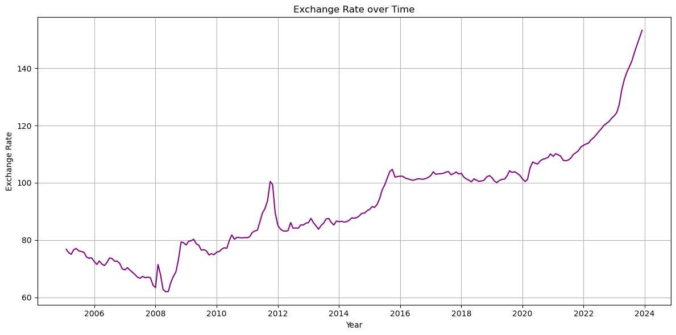

Key periods to notice;

1. **2005 - 2008** : We can see the Kenyan Shilling growing in strength steadily.
2. **2008 - 2009** : We see a sharp increase here we see it weakening, we could attribute this to the previous 2007 election period scuffles that occured.
3. **2011 - 2012** : Another election period coming up and as such with the tension seen previously, we can see another hit the shilling took.
4. **2012 - 2016** : We see a steady weakening of the shilling and it weeakens futher approaching 2017.
5. **2017 - 2018** : Despite being an election period, the currency was fairly stable.
6. **2022 - 2024** : The sharp rise could be attributed to government borrowing, and also the impending payment periods for the loans previously taken.

* **Banking Rates vs Exchange Rate:**  
  Inflation contained monthly data from 2005 to 2025 (KNBS), so we had to fill in the remaining 2003-2004 using the mean.

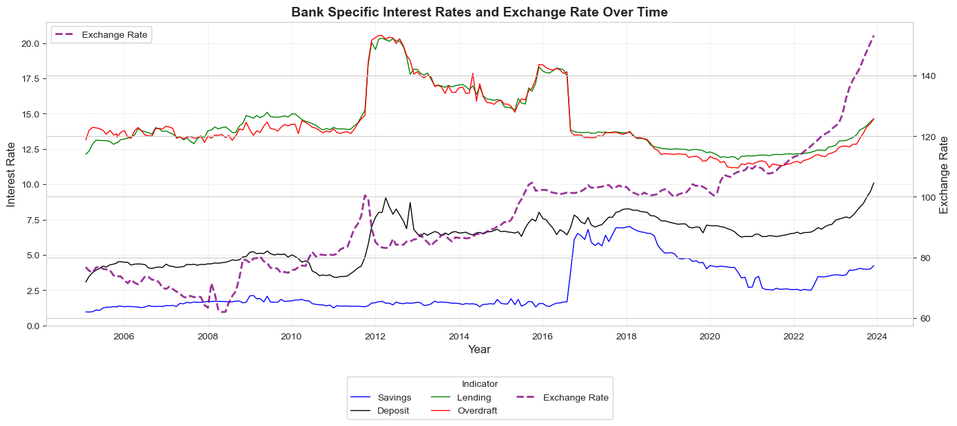

Key takeaways;

1. The deposit interest rate often closely mirrors the exchange rate. This can be attributed to the weakening of the local currency, which leads to reduced investment activity. As a result of the lower demand for fixed deposits, banks are compelled to raise interest rates in order to attract more funds.
2. Lending and Overdraft have very little effect on the exchange rate.

Correlation to exchange rate;

1. Savings - 0.55
2. Deposit - 0.74
3. Lending – (-0.21)
4. Overdraft – (-0.25)

* **Total Debt and Total Remittances vs Exchange rate:**  
  Monthly data on domestic and external debt from 2000 to 2021 (CBK). We cut off the data to 2003 and filled in the remaining 2022 – 2023 with the mean.

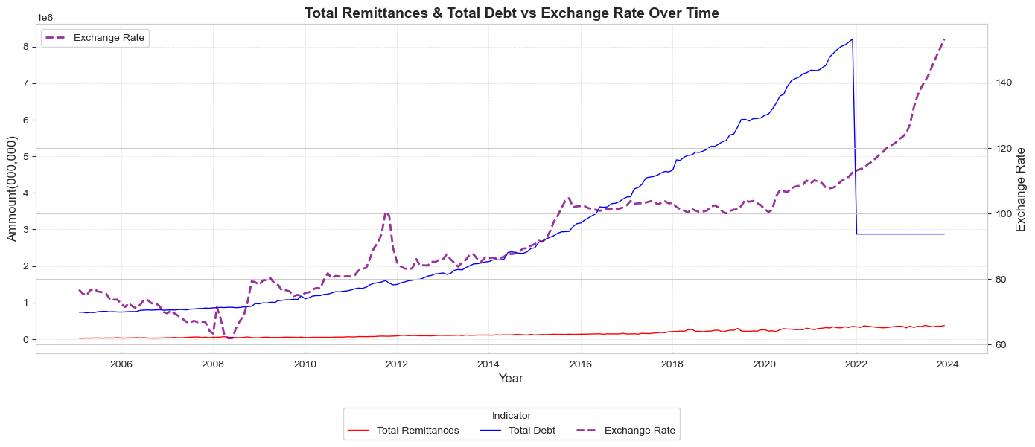

Insights;

1. Remittances have remained steady over the years.
2. The country may have been using external debt to cushion the currency, however as soon as the repayment matured and Kenya made it the currency greatly weakened due to the currency outflow.

Correlation;

1. Total Debt – 0.75
2. Total Remittances – 0.91

* **Interbank and Central Bank Interest rates vs Exchange rate:**  
  Monthly data from 2003 to 2023 (CBK).

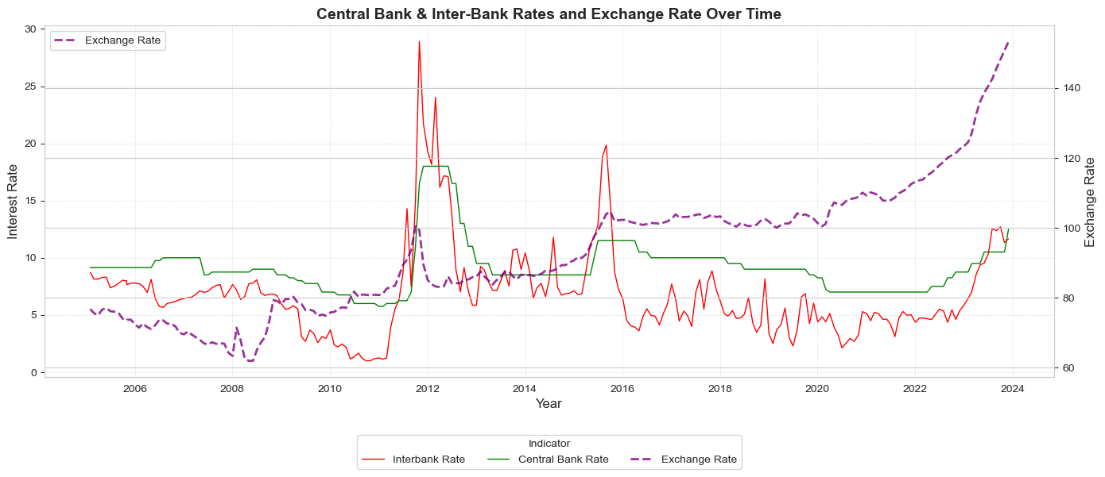

Insights;

1. We didn't use cash reserve in the plot as the movement is static and doesn’t follow demand/supply.
2. The movements seen and pattern in the above plot is purely coincidental as the correlation tells a different story.
3. Interbank Rate spikes reflect market stress or tightening liquidity.
4. Times when the exchange rate diverges from interest rate trends—indicating external or market-driven factors.

Correlation;

1. Interbank – 0.04
2. Central Bank – 0.01
3. Cash reserve requirement – (-0.67) – Despite the high correlation, the rate is set arbitrarily and as such is not controlled by market forces.

* **Treasury Bills (91-Day, 182-Days, 364-Days) Rate vs Exchange rate:**  
  Annual data from 1991 to 2023 (CBK). We cut off the data to 2003.

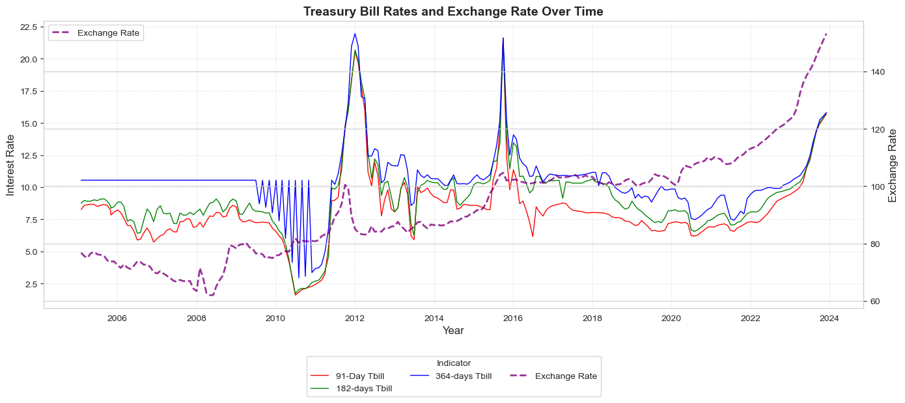

Insights;

1. The flat line at the beginning of the 364-Tbill(blue), was due to lack of data and also by filling it in using mean, we would have a flat line.
2. The interest rates on the T-bills tend to follow the exchange rate closely, this is because the government tries, to mop up excess money in circulation using bonds thus preventing it leaving the country and weakening the shilling further.
3. Also the lower correlation, in the 364-Tbill would imply that the interest rate movements are made to counter on a shorter term basis compared to long-term.

Correlation;

1. 91-Day Tbill - 0.31
2. 182-Day Tbill - 0.32
3. 364-Day Tbill - 0.12

* **Inflation Rate vs Exchange rate:**  
  Annual data from 1991 to 2023 (KNBS). We cut off the data to 2003.

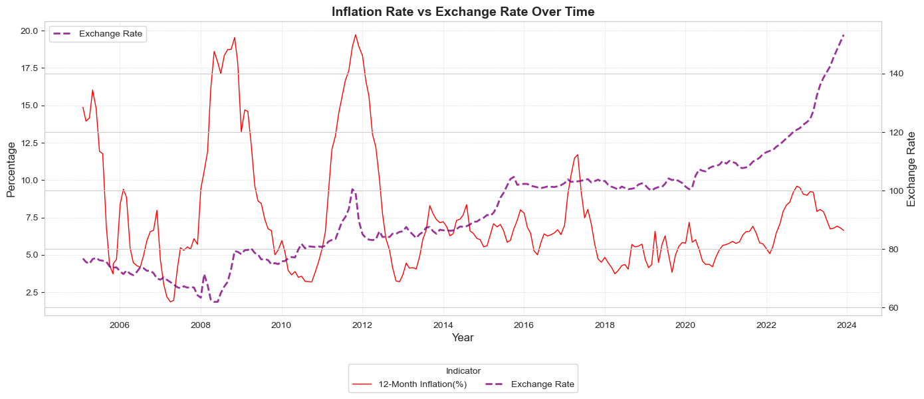

Insights;

1. Inflation has very little effect on exchange rate. However, significant similar spikes are seen around the election periods of 2012, 2017.

Correlation;

1. 12-Month Inflation(%) – (-0.17)

* **Treasury bills vs Inflation (additional):**  
  This was done to show the significance and inter-relationship.

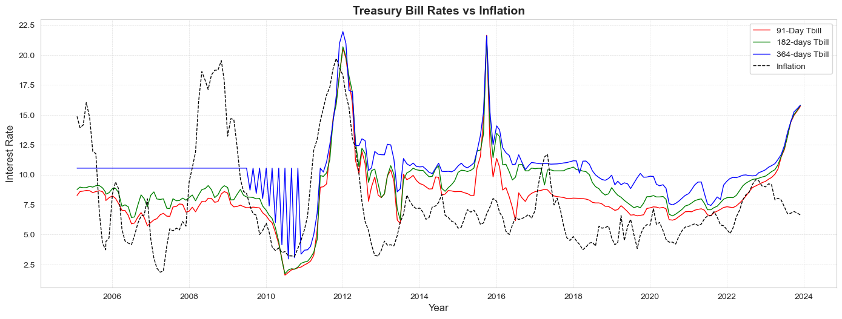

Insights;

1. The above plot proves the close relationship between inflation and Treasury bills, and how they are used a fiscal tool to control the inflation rate. However, we see that the influences are not so significantly strong hence why treasury bills are used in conjunction with other methods to stabilize inflation.

Correlation against inflation;

1. 91-Day Tbill - 0.40
2. 182-Day Tbill - 0.34
3. 364-Day Tbill - 0.33

* **Imports and Exports vs Exchange Rate:**  
  Annual data from 1991 to 2023 (KNBS). The data was recorded yearly, and as such we used the yearly aggregated dataset.

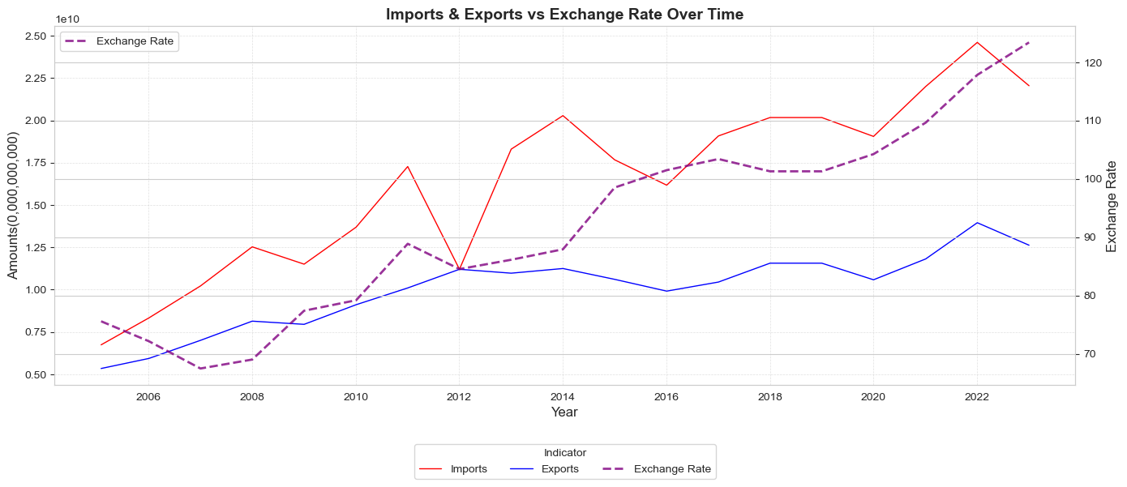

Insights;

1. Kenya is a net importer however our exports are following closely.
2. As the imports rise, so does the exchange rate as money is flowing out of the country.
3. This is cushioned by our exports as money comes back in that strengthens the currency.

Correlation;

1. Imports – 0.86
2. Exports – 0.83

* **Foreign Direct Investment and IBRD loans and IDA credits (DOD, current US$) vs Exchange rate:**  
  Annual data from 2000 to 2023 (Macrotrends.net). We cut off the data to 2003.

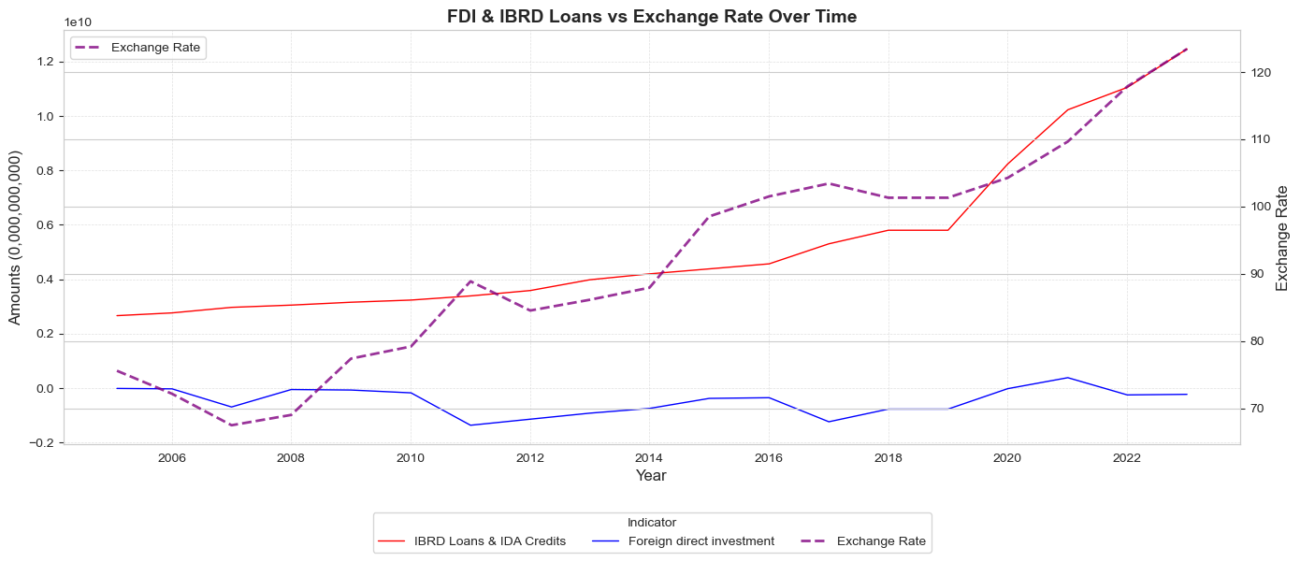

Insights;

1. The more we borrow, the weaker the shilling becomes.

Correlation;

1. IBRD Loans & IDA Credits – 0.89
2. Foreign Direct Invest – 0.02

* **Unemployment Rate vs Exchange Rate:**  
  Annual data from 1991 to 2023 (KNBS). Cut off to 2003.

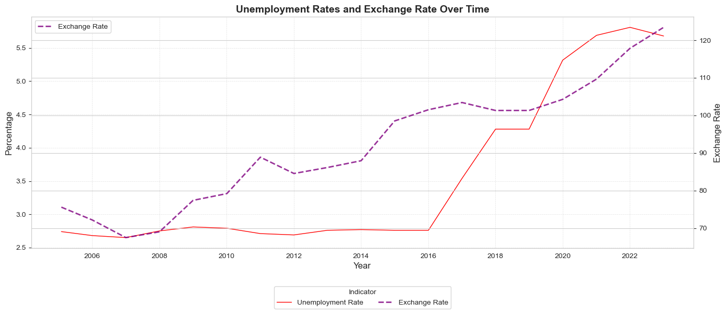

Insights;

1. The rise in unemployment is due to jobs not being created because there is low investment in the country, the effect doesn't show until much later as companies don't close down immediately we see a drop in currency value, but it catches up eventually.

Correlation;

1. Unemployment – 0.82

* **Cross Correlation for all the variables:**

We implemented this so as to give us a sky view of everything we had done, and also not done and to help guide some models for key features to use to potentially increase perfoemance.

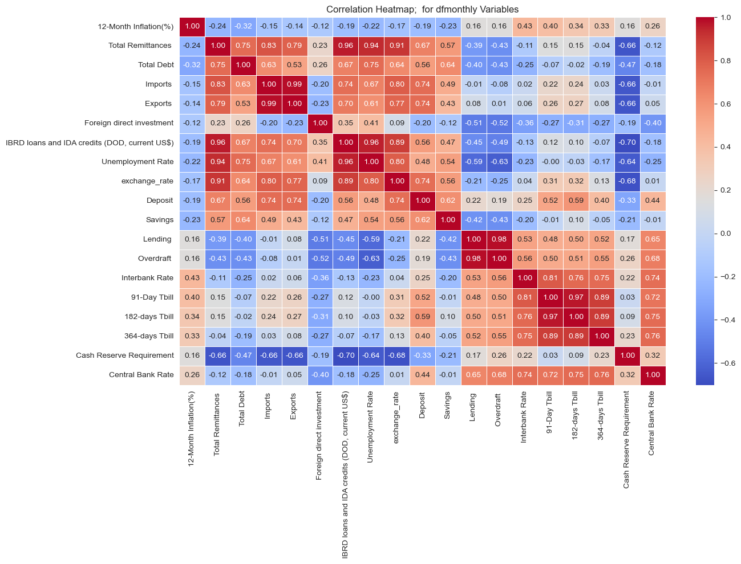

**Modeling Outcome and Evaluation Strategy**

After modelling, this are the results we got for each best performing model;

:

|  |  |  |  |  |  |  |
| --- | --- | --- | --- | --- | --- | --- |
| ***Model***  ***Metric*** | **ARIMA** | **EXPONENTIAL SMOOTHING** | **PROPHET** | **MOVING AVERAGE** | **LSTM** | **XG BOOST** |
| **RMSE** | *22.360* | *1.644* | *2.614* | *20.572* | *6.051* | *2.737* |
| **MSE** | *486.684* | *2.703* | *6.830* | *423.223* | *36.612* | *7.490* |
| **MAE** | *17.491* | *1.002* | *2.007* | *17.893* | *4.503* | *1.538* |
| **MAPE** | *14.040* | *1.149%* | *2.200%* | *12.455%* | *3.540%* | *1.620%* |
| **R² Score** | *-1.766* | *0.992* | *0.979* | *-3.510* | *0.768* | *0.974* |

**Comparison of Forecasted Values**

|  |  |  |  |  |  |  |  |
| --- | --- | --- | --- | --- | --- | --- | --- |
| ***Model***  **Date** | **ARIMA** | **EXPONENTIAL SMOOTHING** | **PROPHET** | **MOVING AVERAGE** | **LSTM** | **XG BOOST** | **ACTUAL**  **(CLOSING)** |
| **Dec – 2023** |  | *155.13* | *144.60* | *154.95* |  |  | *154.09* |
| **Jan – 2024** | *254.87* | *157.01* | *147.06* | *155.44* | *141.23* |  | *159.69* |
| **Feb – 2024** | *356.63* | *158.90* | *147.06* | *155.47* | *141.32* |  | *151.84* |
| **Mar – 2024** | *458.53* | *160.78* | *148.29* | *155.60* | *140.67* |  | *137.35* |
| **Apr – 2024** | *560.56* | *162.67* | *148.54* | *155.56* | *139.72* |  | *131.57* |
| **May – 2024** | *662.72* | *164.55* | *148.36* | *155.54* | *138.69* |  | *131.69* |
| **Jun – 2024** | *765.02* | *166.44* | *169.22* | *155.40* | *137.67* |  | *129.36* |
| **July – 2024** | *867.45* | *168.32* | *151.92* | *155.39* | *136.70* |  | *129.87* |
| **Aug – 2024** | *970.02* | *170.21* | *152.06* | *155.37* | *135.80* |  | *129.32* |
| **Sep – 2024** | *1072.71* | *172.09* | *171.16* | *155.27* | *134.95* |  | *129.20* |
| **Oct – 2024** | *1175.55* | *173.98* | *154.02* | *155.14* | *134.16* |  | *129.20* |
| **Nov – 2024** | *1278.51* | *175.86* | *156.24* | *154.96* | *133.42* |  | *129.40* |
| **Dec – 2024** | *1381.61* |  | *173.63* |  | *132.72* |  | *129.36* |

**Conclusion and Recommendation**

1. **Features**

From our exploratory analysis, we came to the conclusion that the following features have the most influence on/are influenced by the exchange rate;

1. Imports & Exports
2. IBRD Loans & IDA Credits
3. Unemployment
4. Bank Deposit Rate
5. Savings
6. Total Debt
7. Total Remittances

For a future and ongoing analysis after this one, these would be the key features to consider in the analysis.

1. Models

From the above tables, we can see very mixed reactions from the metrics and forecasted values;

Ranking by metrics;

1. Exponential Smoothing
2. Prophet
3. XG Boost
4. LSTM
5. ARIMA
6. Moving Average

Ranking by Forecast Accuracy;

1. LSTM
2. Moving Average
3. Prophet
4. Exponential Smoothing
5. ARIMA

We highly suggest deploying on the LSTM and Moving Average models as these had the best forecasts.

**Deployment and Practical Application**

Deployment could be implemented using platforms such as **Streamlit**, **Power BI**, or integrated into a **Python Flask API** for web-based accessibility.